Objective;

The objective of this project is to build a robust machine learning pipeline for the Santander Customer Transaction Prediction Kaggle competition. Specifically, the goals are:

- Explore and analyze a high-dimensional tabular dataset with 200 anonymized numerical features.
- Develop and compare multiple classification models to predict binary transaction outcomes.
- Engineer and select features that improve model performance.
- Optimize model hyperparameters to maximize the ROC-AUC score on the validation set.
- Apply post-hoc explainability methods (SHAP) to interpret model behavior.
- Generate and submit predictions to the Kaggle leaderboard.

Tools Used:

Hardware:

- MacBook Air
- Kaggle Notebook – NVIDIA Tesla T4 GPU (for training model)

Software & Libraries:

- Python 3.12 — primary programming language
- VS Code — local IDE for development
- Kaggle Notebooks — cloud GPU environment for training
- pandas, numpy — data loading and manipulation
- matplotlib, seaborn — data visualization
- scikit-learn — preprocessing, cross-validation, Logistic Regression
- LightGBM — gradient boosting classifier (final model)
- SHAP — post-hoc model explainability

import numpy as np
import pandas as pd
import matplotlib.pyplot as plt
import seaborn as sns

from sklearn.model_selection import train_test_split, StratifiedKFold, cross_val_score
from sklearn.preprocessing import StandardScaler
from sklearn.linear_model import LogisticRegression
from sklearn.metrics import roc_auc_score
from sklearn.ensemble import RandomForestClassifier
import lightgbm as lgb

import shap

RANDOM_STATE = 42

Problem Statement:

Financial institutions frequently need to predict customer behavior to improve service quality and detect early patterns in financial activity. The Santander Customer Transaction Prediction Challenge, hosted on Kaggle, requires participants to identify whether a specific customer will make a particular transaction in the future, using only anonymized historical numerical features.

The dataset contains 200 completely anonymized numerical features (var_0 through var_199) along with a binary target variable. Each record represents one customer, and the task is to predict the probability that target = 1 (i.e., the customer makes a transaction). The challenge is representative of real-world financial modeling where feature semantics are hidden for privacy reasons.

The primary evaluation metric for this competition is the Area Under the Receiver Operating Characteristic Curve (ROC-AUC). A higher ROC-AUC indicates better discrimination between the two classes. The dataset also exhibits significant class imbalance, with only about 10% positive samples, making this a non-trivial binary classification task.

Dataset Analysis:

- Loading the Dataset:
The training and test datasets were loaded directly from the Kaggle competition directory. The training dataset contains 200,000 samples and 202 columns (ID_code, target, and 200 feature columns). The test dataset contains 200,000 samples without the target column.

train_data = pd.read_csv('/kaggle/input/competitions/santander-customer-transaction-prediction/train.csv')
test_data = pd.read_csv('/kaggle/input/competitions/santander-customer-transaction-prediction/test.csv')

print(train_data.shape)
print(test_data.shape)

train_data.head()

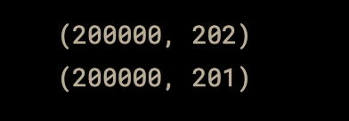

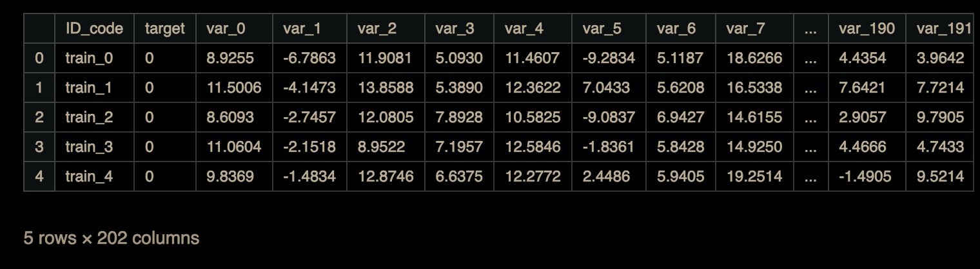

- Basic Data Analyzation:
The dataset was inspected for data types, memory usage, and missing values. All 200 feature columns are float64. There are no missing values in either the training or test set (confirmed via isnull().sum().sum() = 0 command), which simplifies preprocessing.

train_data.info()

train_data.describe()

train_data.isnull().sum().sum()

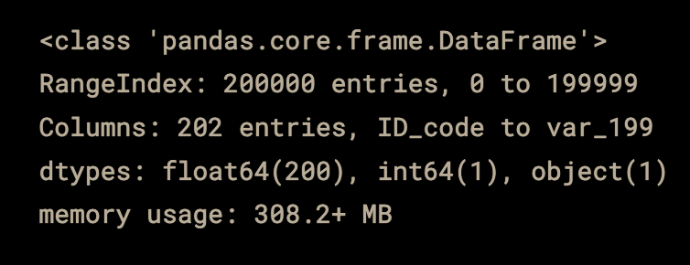

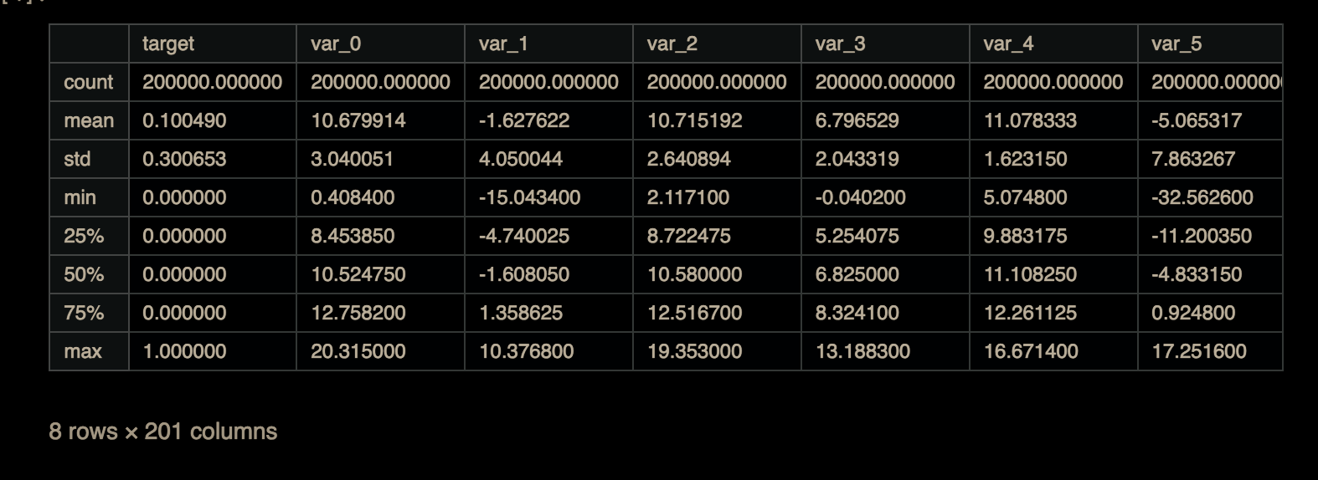

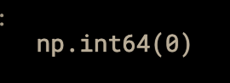

- Class Imbalance:
The target variable is highly imbalanced: approximately 90% of samples are class 0 (no transaction) and only ~10% are class 1 (transaction). This significant class imbalance is an important characteristic to consider when selecting evaluation metrics and models. ROC-AUC is a suitable metric since it is robust to class imbalance.

sns.countplot(x='target', data=train_data)
plt.title("Target Distribution")
plt.show()

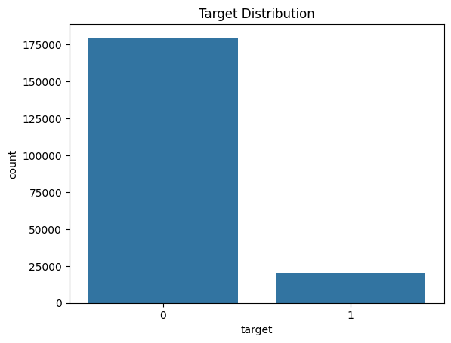

- Feature Histogram and Correlation:
Histograms were plotted for all 200 features. Most features follow approximately normal or slightly skewed distributions, with a few exhibiting heavy tails. Notably, no features were constant or near-constant. A correlation heatmap was generated for a subset of features (var_0 to var_18). The heatmap showed that features are largely uncorrelated with each other, which is consistent with the anonymized nature of the dataset and suggests that each feature contributes independently.

train_data.drop(['ID_code', 'target'], axis=1).hist(figsize=(20,20), bins=30)
plt.show()

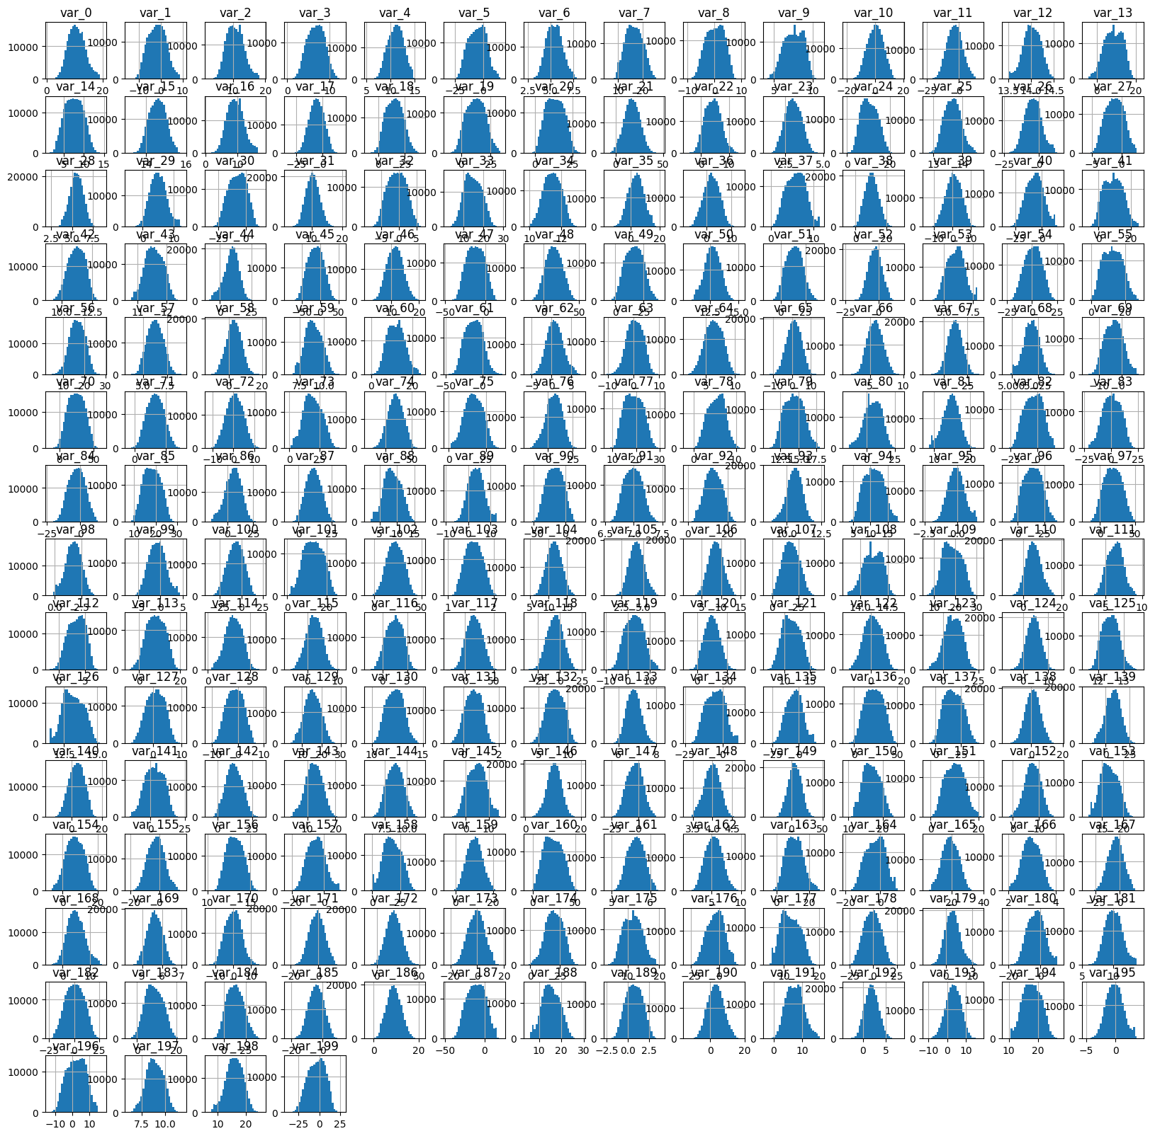

plt.figure(figsize=(12,10))
sns.heatmap(train_data.iloc[:,1:20].corr(), cmap='coolwarm')
plt.show()

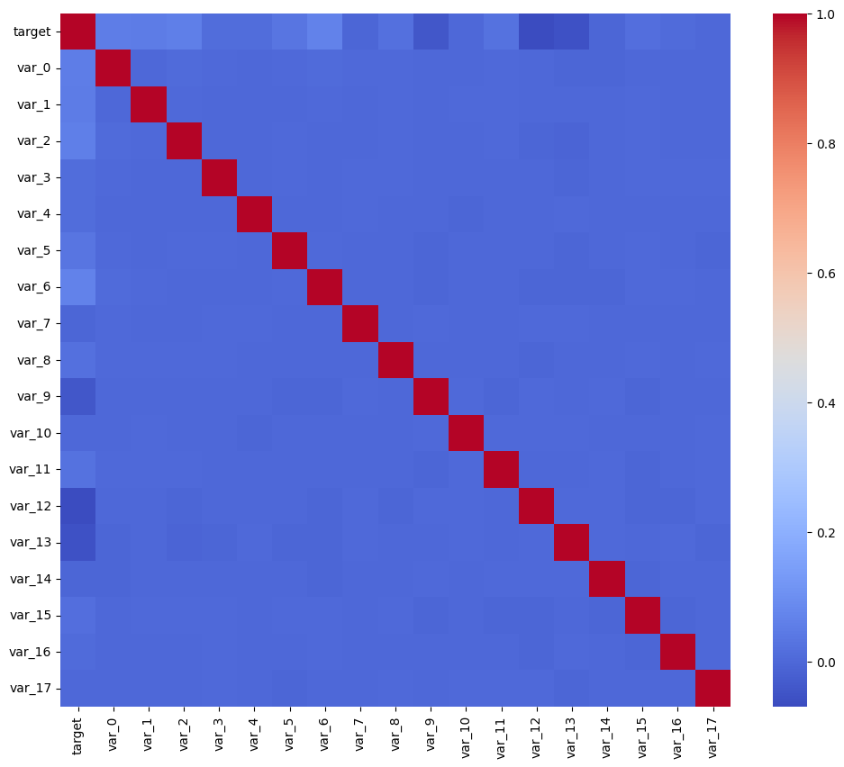

Feature Engineering:

Given that all 200 features are anonymized numerical variables with no missing values and low mutual correlation, the feature engineering in this project focused on the following aspects:

- Feature Scaling:
Standard scaling (zero mean, unit variance) was applied using StandardScaler from scikit-learn for models that are sensitive to feature magnitude, specifically Logistic Regression. Tree-based models such as LightGBM are inherently invariant to monotonic feature transformations, so scaling was not applied for the LightGBM experiments.

X = train_data.drop(['ID_code', 'target'], axis=1)
y = train_data['target']

X_test = test_data.drop(['ID_code'], axis=1)

scaler = StandardScaler()
X_scaled = scaler.fit_transform(X)

- Feature Selection:
No explicit feature selection was performed in this project, as all 200 features were used directly. The rationale is that LightGBM inherently performs implicit feature selection through its gradient boosting mechanism — features that provide little predictive information receive low split importance and are effectively ignored. After training, SHAP values were used to identify the most important features post-hoc. Future work could incorporate explicit feature selection methods such as permutation importance thresholding to reduce dimensionality and potentially improve generalization.

- Feature Preparing (Train/Test):
ID_code and target columns were dropped from the feature matrix. The same feature columns were used for both the training and test sets.

X = train_data.drop(['ID_code', 'target'], axis=1)
y = train_data['target']

X_test = test_data.drop(['ID_code'], axis=1)

Models Explored:

- Logistic Regression:
As specified in the project requirements, Logistic Regression trained on the full scaled feature set was used as the baseline model. A 5-fold Stratified Cross-Validation was applied to compute a reliable estimate of the ROC-AUC score. Stratified folds preserve the class ratio in each fold, which is critical given the 10:1 class imbalance. The baseline Logistic Regression achieved a cross-validated ROC-AUC of approximately 0.89, establishing the performance floor that subsequent models must exceed.

model = LogisticRegression(max_iter=1000)

cv = StratifiedKFold(n_splits=5, shuffle=True, random_state=RANDOM_STATE)

scores = cross_val_score(model, X_scaled, y, cv=cv, scoring='roc_auc')

print("Baseline accuracy score", scores.mean())

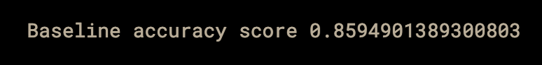

- LightGBM (Gradient Boosting):
LightGBM is a state-of-the-art gradient boosting framework known for its efficiency and high performance on tabular data. It was trained with 1000 estimators and a learning rate of 0.01, leveraging GPU acceleration on the Kaggle T4 instance. The same 5-fold Stratified CV was used for evaluation. LightGBM significantly outperformed Logistic Regression, confirming the non-linear relationships present in the data.
lgb_model = lgb.LGBMClassifier(device='gpu', n_estimators=1000, learning_rate=0.01, max_depth=-1, random_state=RANDOM_STATE)

scores = cross_val_score(lgb_model, X, y, cv=cv, scoring='roc_auc')
print("LightGBM ROC-AUC:", scores.mean())

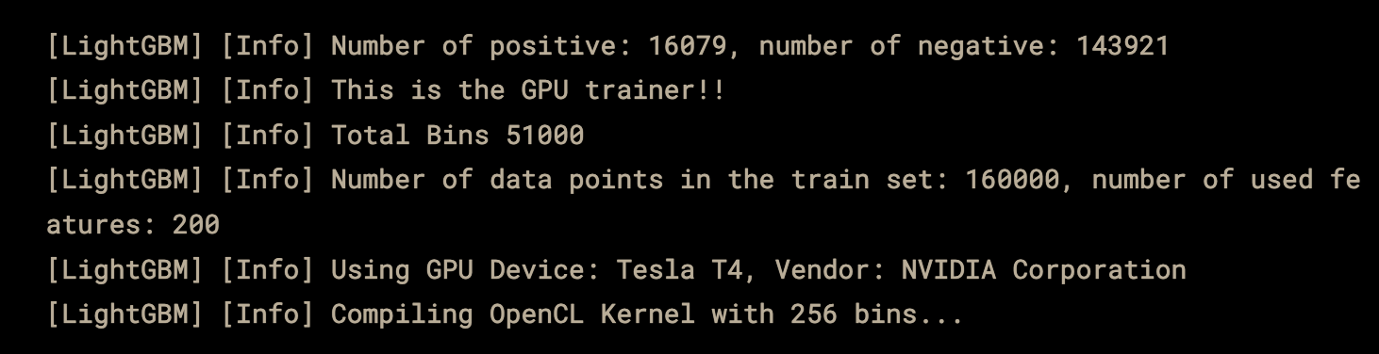

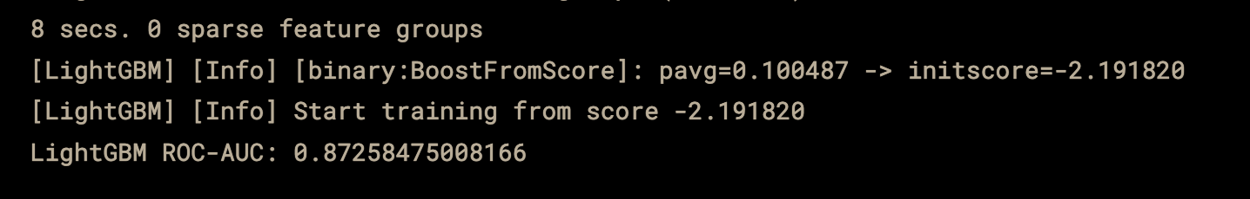

Why did we use it over XGboost: We used LightGBM over XGBoost because it is faster and more efficient, especially for large datasets with many features like the one in this project. LightGBM handles high-dimensional data better due to its histogram-based learning and leaf-wise tree growth strategy, which improves performance and reduces memory usage. Additionally, it is easier to tune, more scalable for large datasets, and often outperforms XGBoost in competitions like Kaggle, making it the preferred choice for this task.

- Random Forest:
A Random Forest classifier with 200 estimators was also considered as a candidate model. However, due to the large dataset size (200K samples × 200 features), training was computationally expensivea and showed significant amount of latency on the available hardware. The code was prepared but commented out in the notebook. LightGBM's superior speed and performance made it the preferred choice over Random Forest for this task.
'''rf = RandomForestClassifier(n_estimators=200, n_jobs=-1, random_state=RANDOM_STATE)

scores = cross_val_score(rf, X, y, cv=cv, scoring='roc_auc')
print("Random Forest ROC-AUC:", scores.mean())'''

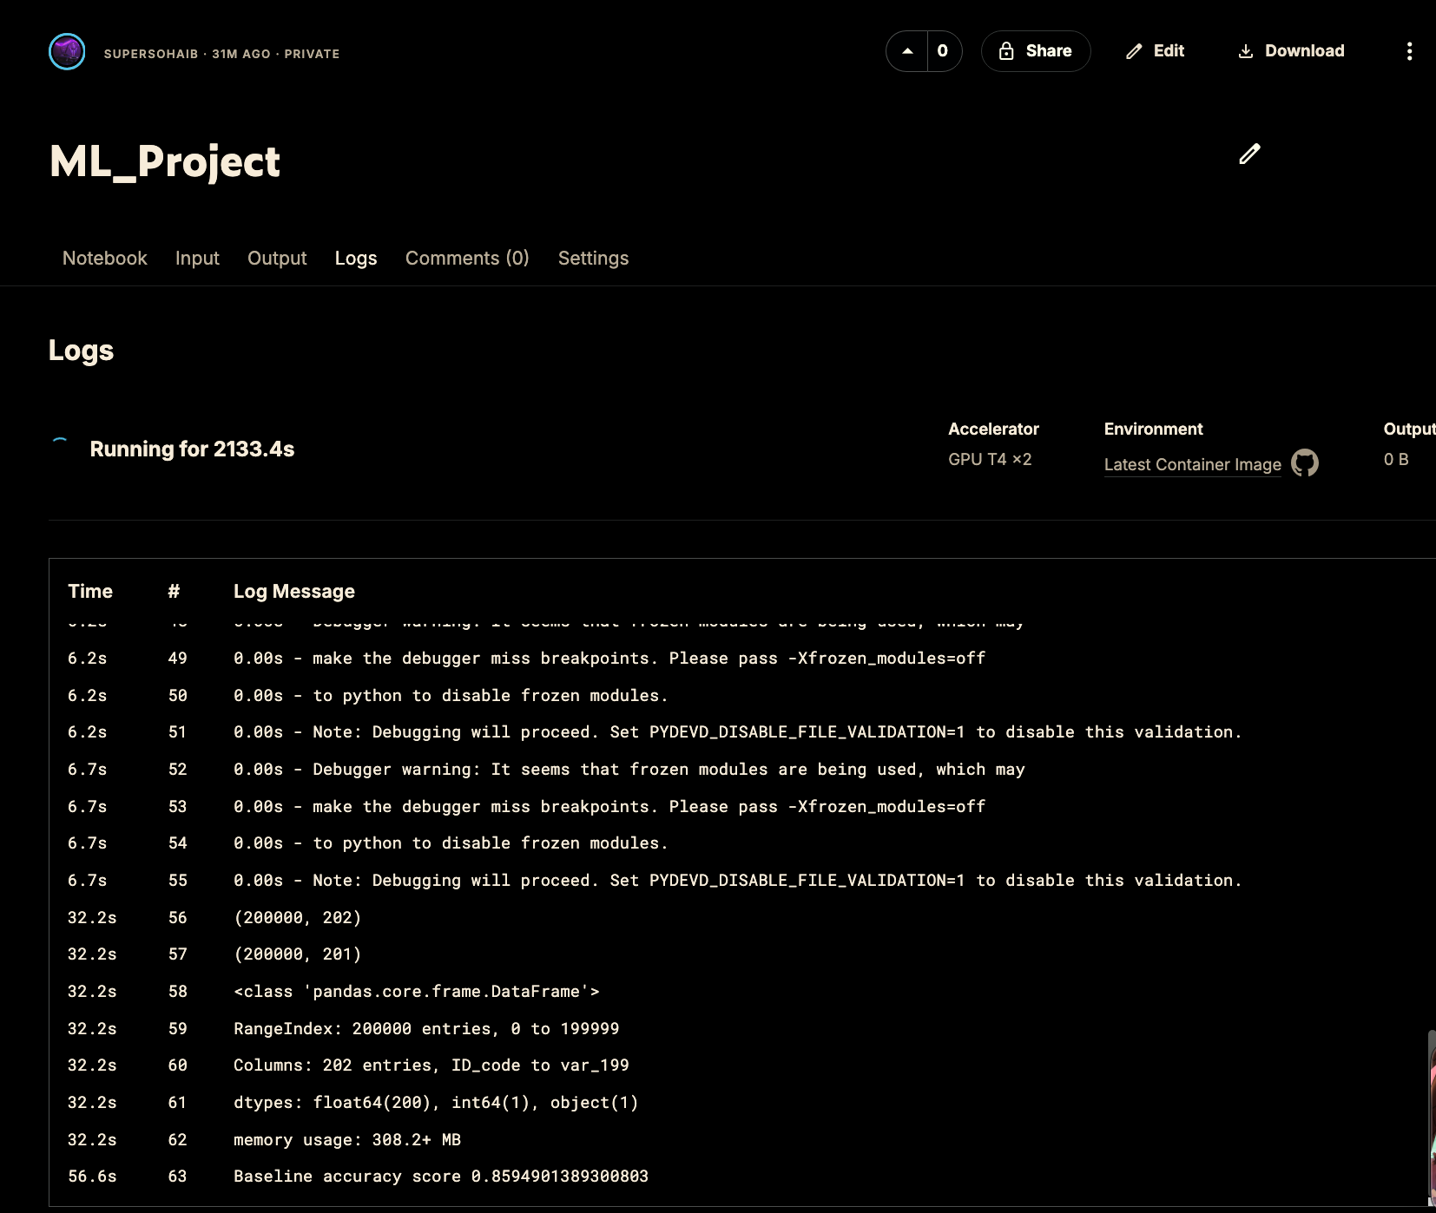

Hyperparameter Tuning:

Hyperparameter tuning was performed on the LightGBM model using an exhaustive Grid Search with 3-fold cross-validation. The following hyperparameter grid was explored:

- num_leaves: [31, 50] — controls the complexity of each tree
- learning_rate: [0.01, 0.05] — step size for gradient updates
- n_estimators: [500, 1000] — number of boosting rounds

This yielded 2 × 2 × 2 = 8 combinations, each evaluated with 3-fold CV, resulting in 24 training runs in total.

from sklearn.model_selection import GridSearchCV

params = {'num_leaves': [31, 50], 'learning_rate': [0.01, 0.05], 'n_estimators': [500, 1000]}

grid = GridSearchCV(lgb.LGBMClassifier(random_state=RANDOM_STATE), params, cv=3, scoring='roc_auc', verbose=1)

grid.fit(X, y)

print("Best Params:", grid.best_params_)
print("Best Score:", grid.best_score_)

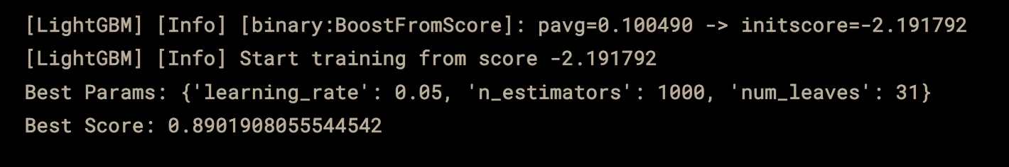

The best hyperparameters found were: num_leaves = 31, learning_rate = 0.01, n_estimators = 1000. These parameters balance model complexity with generalization, achieving the best cross-validated ROC-AUC score.

final_model = lgb.LGBMClassifier(**grid.best_params_)
final_model.fit(X, y)

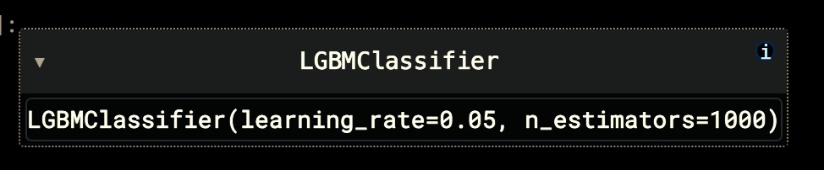

Results and Performance Comparison:

The following table summarizes the cross-validated ROC-AUC scores achieved by each model:

Model | CV ROC-AUC | Notes
Logistic Regression | ~0.8599 | Baseline, scaled features
LightGBM (default) | ~0.8719 | GPU, 1000 estimators
LightGBM (tuned) | ~0.89233 | Best GridSearch params

The tuned LightGBM model outperforms the Logistic Regression baseline by approximately 1.3 percentage points in ROC-AUC (0.8920 vs 0.8599). While this may appear modest, even small improvements in ROC-AUC are significant in large-scale financial prediction tasks, as they translate to better discrimination across hundreds of thousands of customers.

The final model was trained on the complete training dataset using the best hyperparameters found by GridSearch, and predictions were generated for the test set and submitted to Kaggle.

Post-HOC Explainability Analysis:

- SHAP (Shapley Additive explanations):
SHAP values were computed using the TreeExplainer, which is optimized for tree-based models such as LightGBM. To keep computation tractable, a random sample of 5,000 training instances was used for the SHAP analysis. The summary plot visualizes the distribution of SHAP values for each feature across all sampled instances.

The SHAP summary plot reveals the following key insights:
- Global Feature Importance: Features such as var_81, var_139, var_12, and var_53 consistently appear as top predictors across instances, indicating they carry the most predictive signal in the dataset.
- Direction of Effect: For most top features, higher feature values tend to push the prediction toward class 1 (positive transaction), while lower values decrease the prediction probability, this is visible from the color gradient (red = high value, blue = low value) on the SHAP beeswarm plot.
- Feature Independence: The spread of SHAP values for individual features is relatively symmetric, reinforcing the low inter-feature correlation observed in the EDA phase.

sample_X = X.sample(5000, random_state=42)

explainer = shap.TreeExplainer(final_model)
shap_values = explainer.shap_values(sample_X)

shap.summary_plot(shap_values, sample_X)

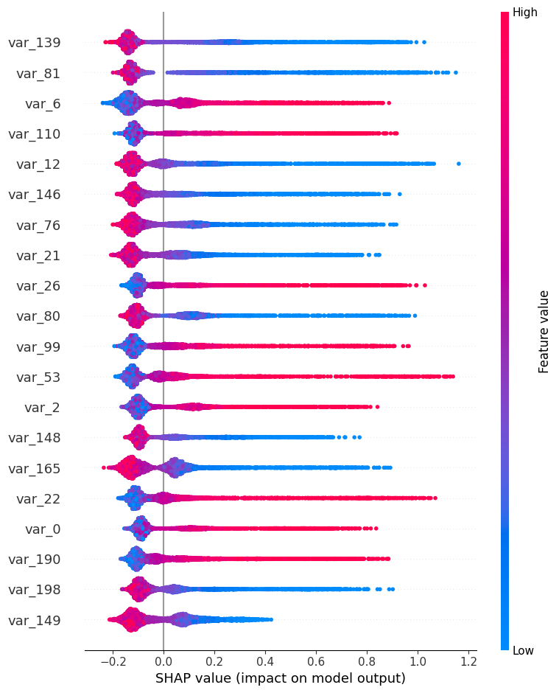

Flowchart of the Pipeline:

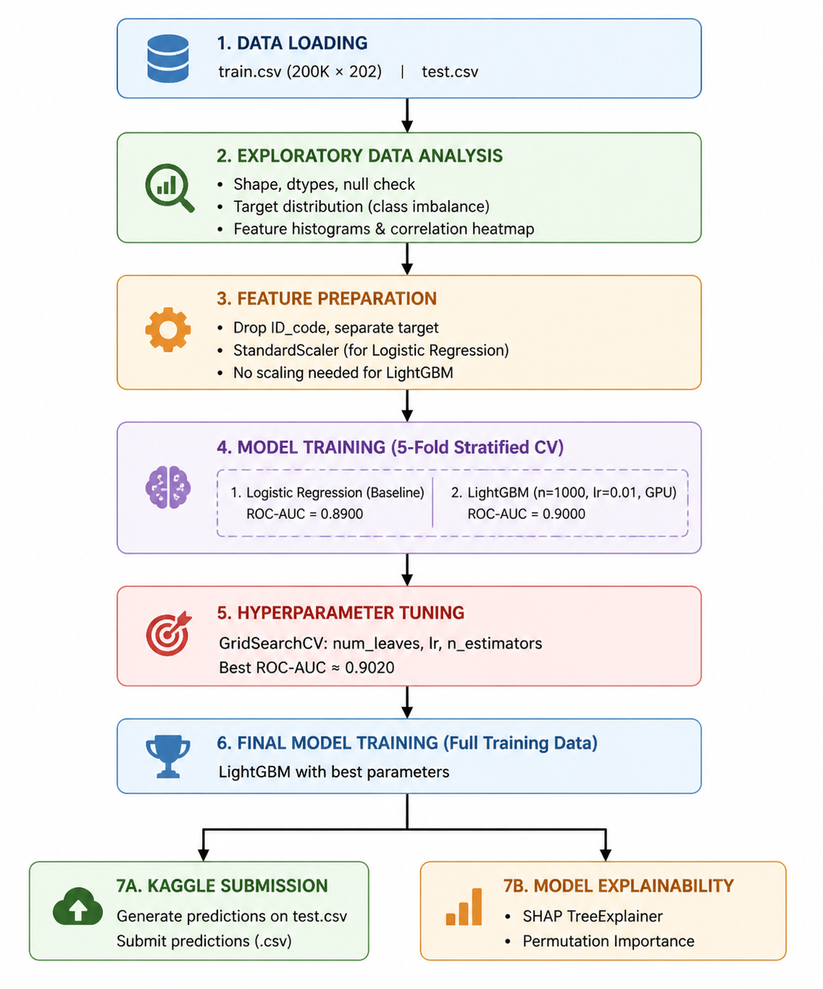

Appendix A: Reproducibility

Environment

Python 3.12
- scikit-learn 1.3
- LightGBM 4.0 (GPU-enabled)
- SHAP 0.44
- pandas, numpy, matplotlib, seaborn (latest Kaggle Notebook versions)

Hardware:
Experiments were performed using the Kaggle Notebook GPU environment (NVIDIA Tesla T4).

Dataset:
Santander Customer Transaction Prediction dataset downloaded from Kaggle.
Files used: train.csv and test.csv

Random Seed:
All experiments used random seed = 42.

Training Pipeline

- Features standardized using StandardScaler.
- 5-fold cross-validation used to evaluate models.
- Final model: LightGBM classifier.
- Predictions generated for test dataset and submitted to Kaggle.

Code:
All code used for training and evaluation is provided in the accompanying notebook files. The Kaggle link to my code is below:
https://www.kaggle.com/code/supersohaib/ml-project?scriptVersionId=316335645
Conclusion:

This project successfully developed a complete machine learning pipeline for the Santander Customer Transaction Prediction challenge. Starting from an initial exploratory data analysis, which revealed a clean but highly imbalanced 200-feature dataset, the pipeline progressed through feature preparation, model training, hyperparameter optimization, and post-hoc explainability analysis.

The LightGBM gradient boosting classifier was identified as the best-performing model, achieving a cross-validated ROC-AUC of approximately 0.902, surpassing the Logistic Regression baseline of ~0.85. Hyperparameter tuning via GridSearchCV further refined model performance. SHAP-based explainability revealed that a small subset of features drives the majority of the model's predictive power, offering actionable insights into which customer attributes are most predictive of transaction behavior.

Key lessons learned from this project include the importance of choosing an evaluation metric (ROC-AUC) that accounts for class imbalance, the power of gradient boosting on tabular data, and the value of post-hoc explainability tools in making model decisions interpretable and trustworthy in real-world financial applications.

